SCREEN PRINT OF MS-EXCEL (LABELLED)

File Name

Formula Bar

Toolbar

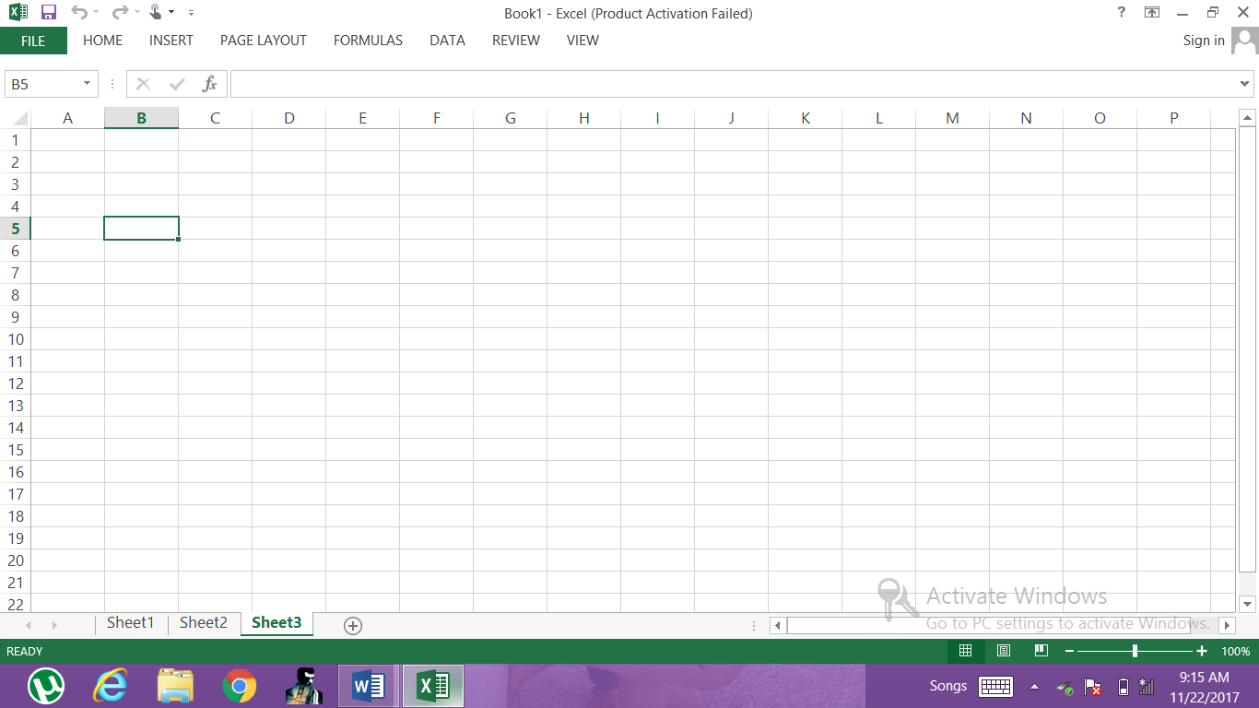

Column Headings

Active Cell

Row Headings

Navigation Buttons

Zoom Bar

Sheet Tabs

Worksheet Window